CS551 Advanced Software Engineering

Fourth Increment Report
Due Date: December 1 (S) 2013, 11:59PM

Contributors: Karthik Repala, Shiva Pothala, Surendra Koripella.

- Import Existing Services/API

API's used:
1. Google Maps API
2.Yahoo Weather API

Services Implemented:

- Check Fuel Implemented
- Find my Car Service(Updated)
- Weather Services (Updated)

- Detail Design of Services

  - Write User Stories /Use Case (Using ScrumDo)

  - Sequence diagram (using Visio)

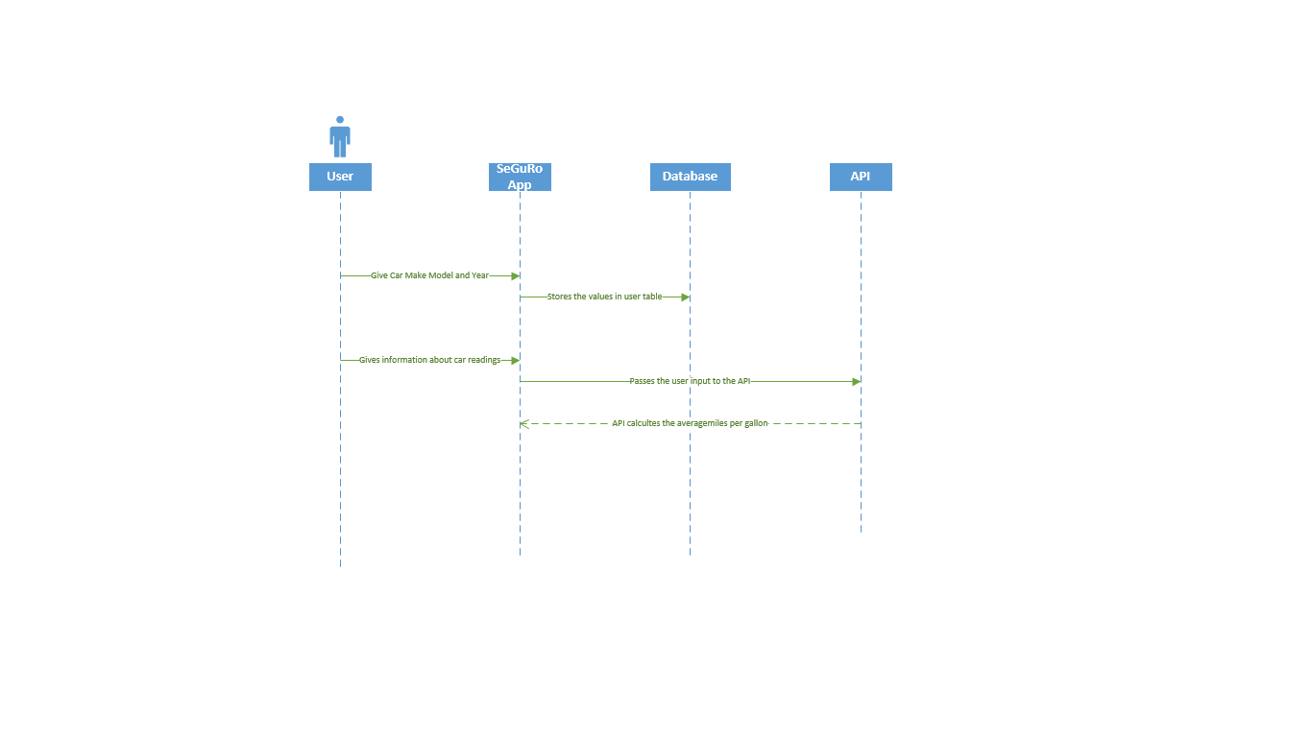

  - Class diagram

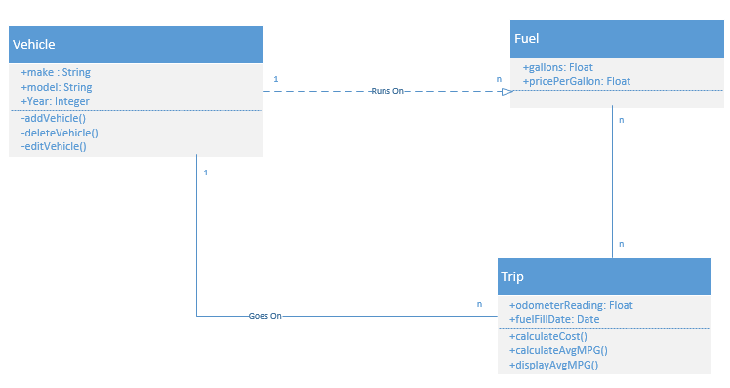

- Report:
The following screen shots provide the entire functionality of the application
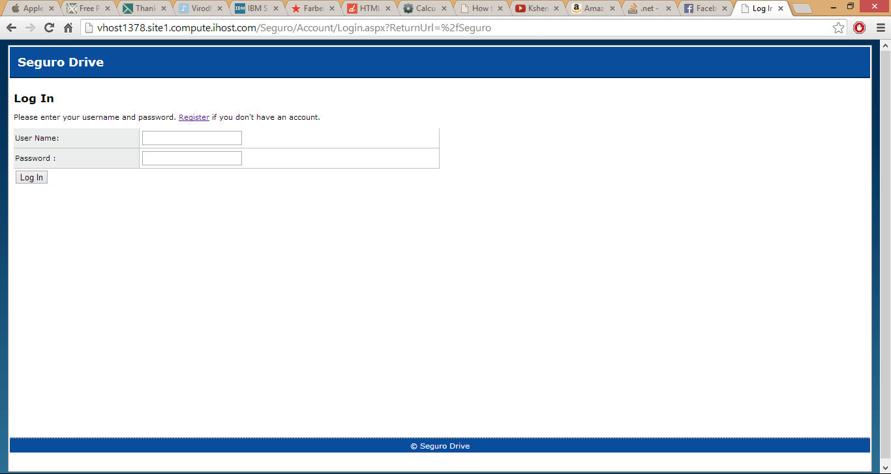
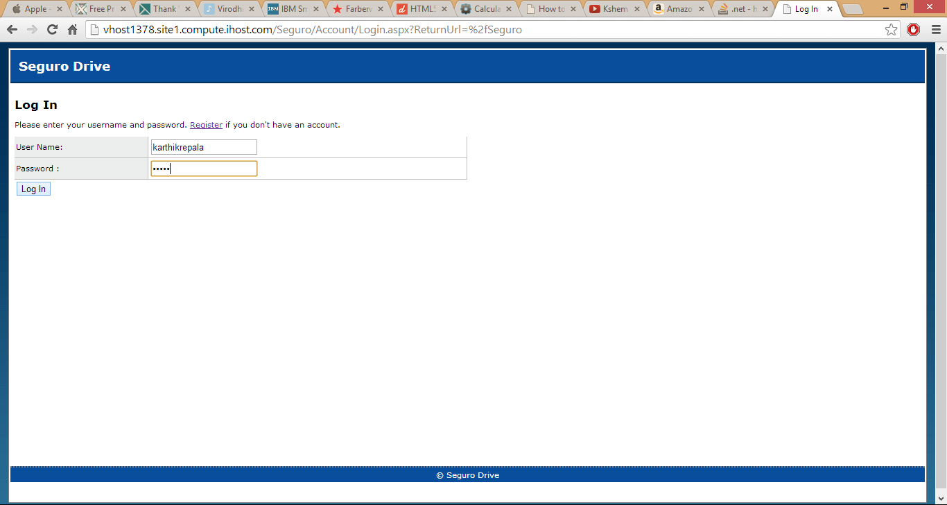

Home Page:

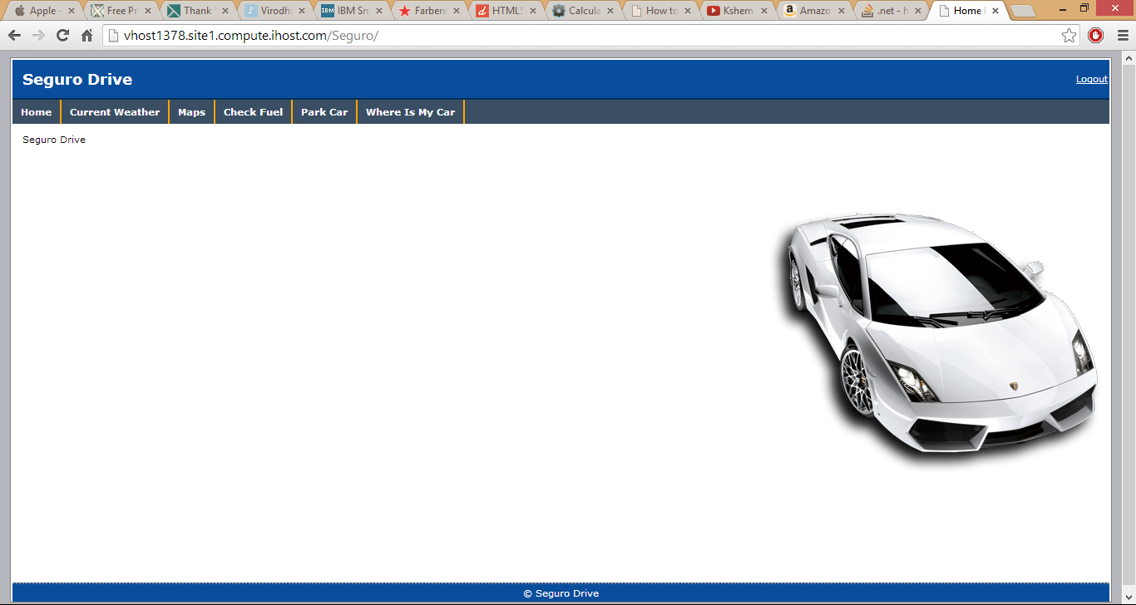

Current Weather:
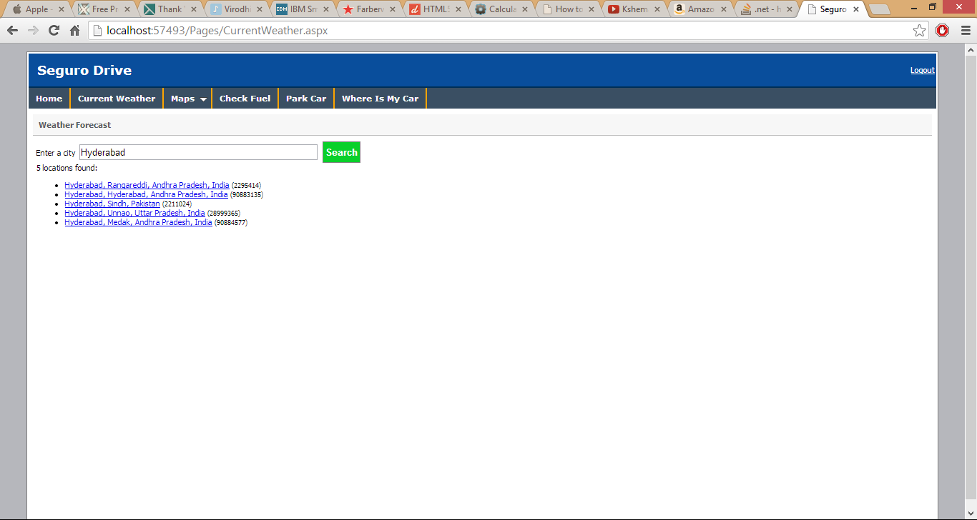
Click on the exact city
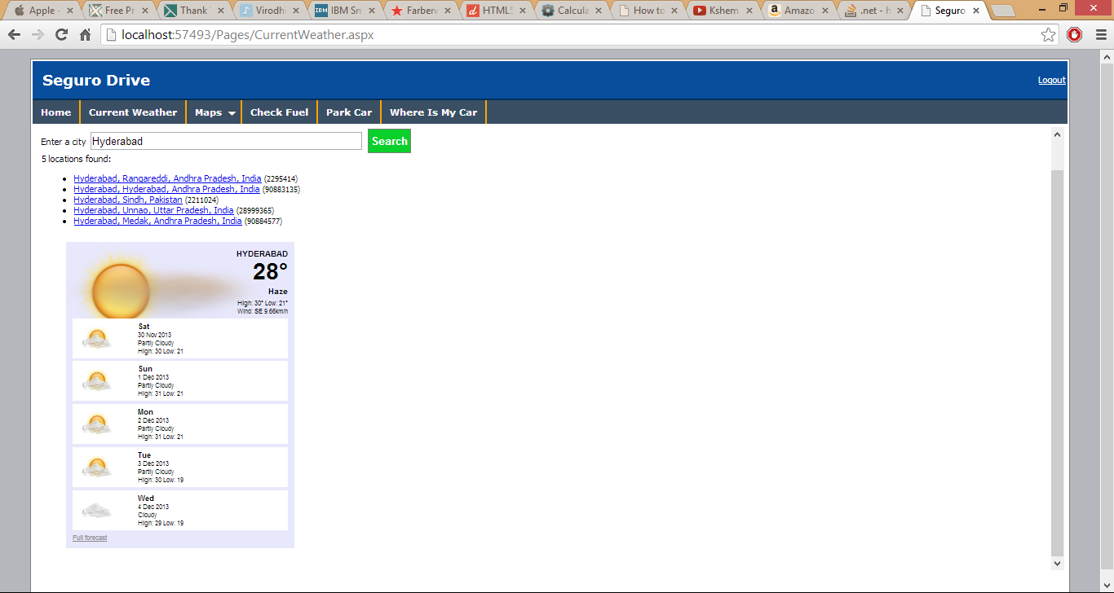

Maps:
Maps has sub categories having Point Map and Geo Location.

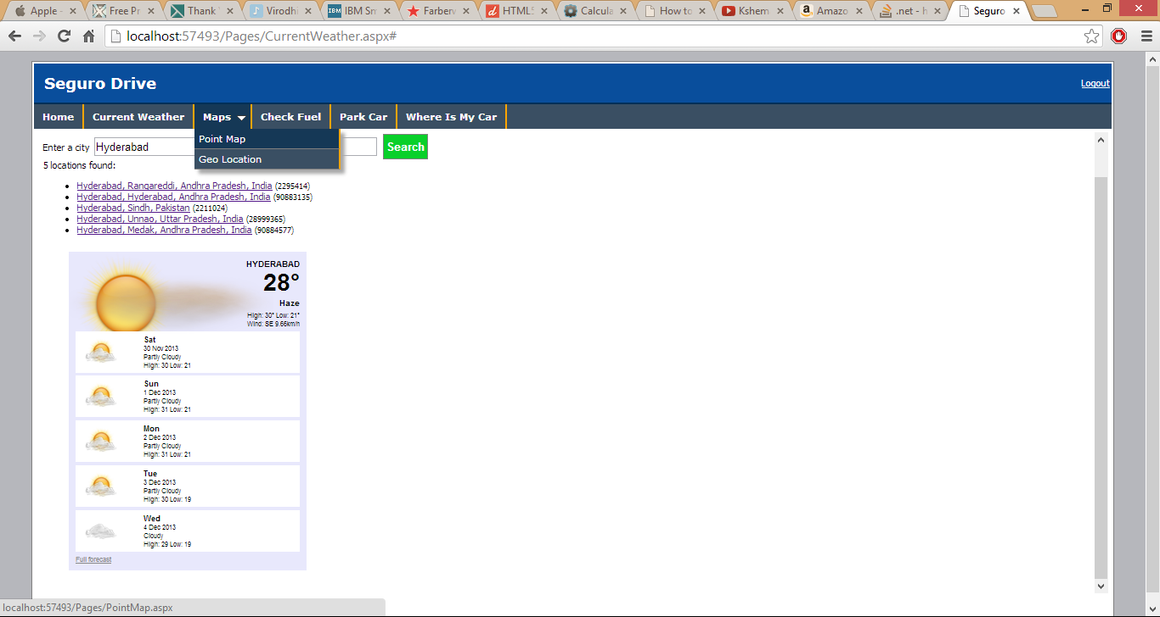

Point Map displays the location of Map when latitude and longitude is entered.
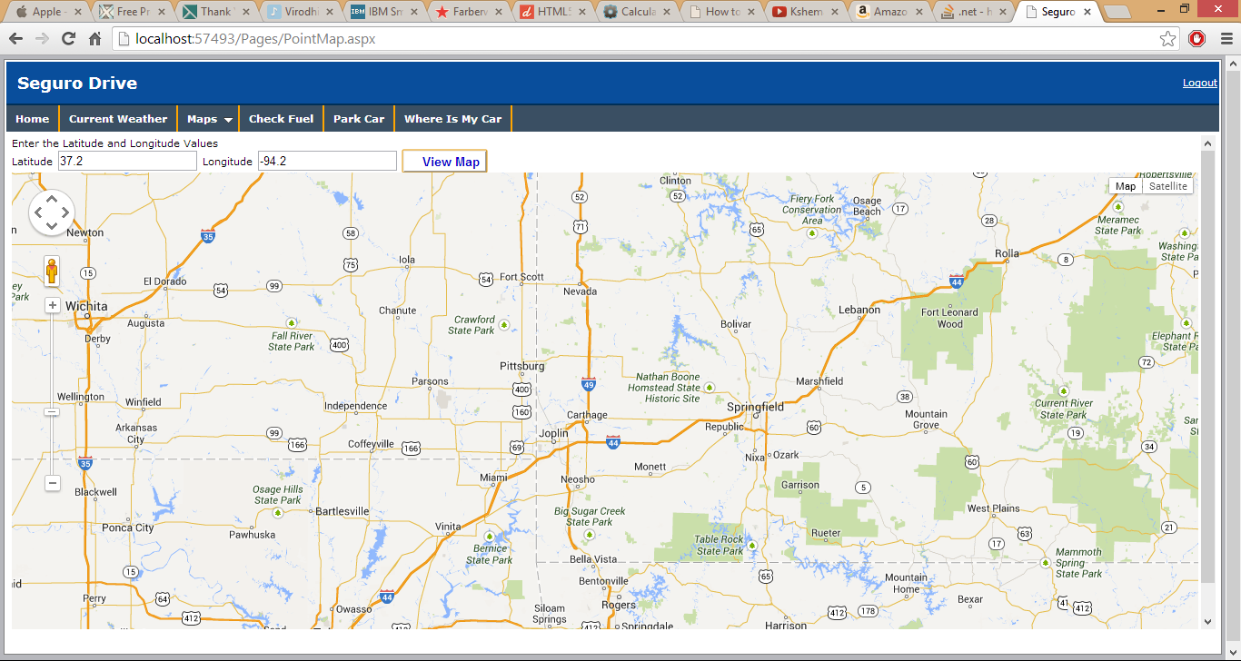

Geo Location gives the directions from the Source A to Source B.
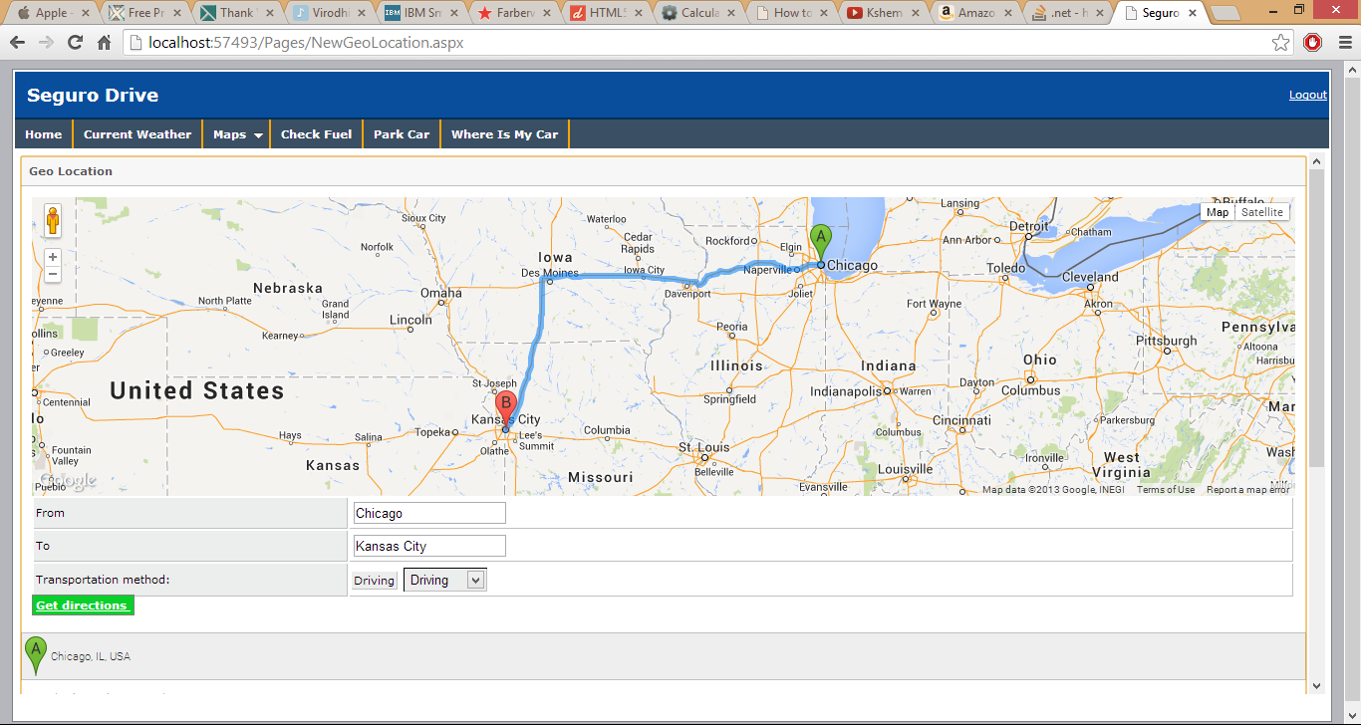
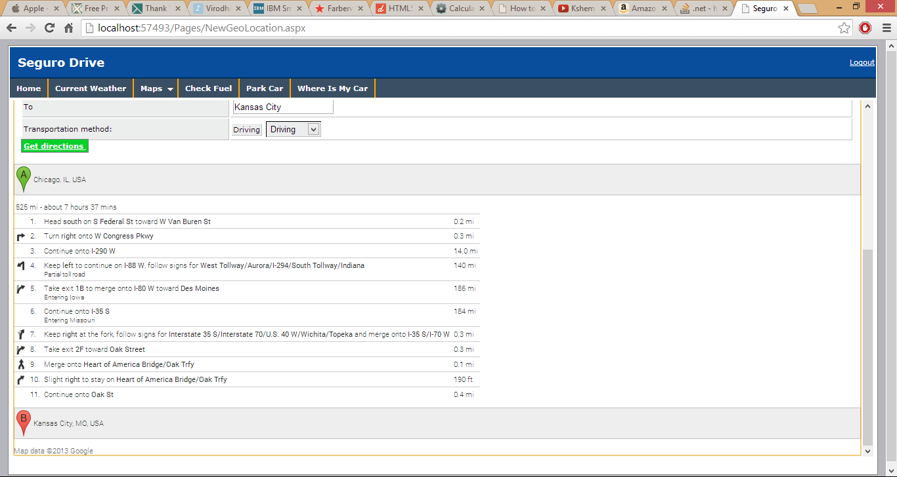
You can even change the tranporation method either to walking or bicycling too.

Check Fuel:
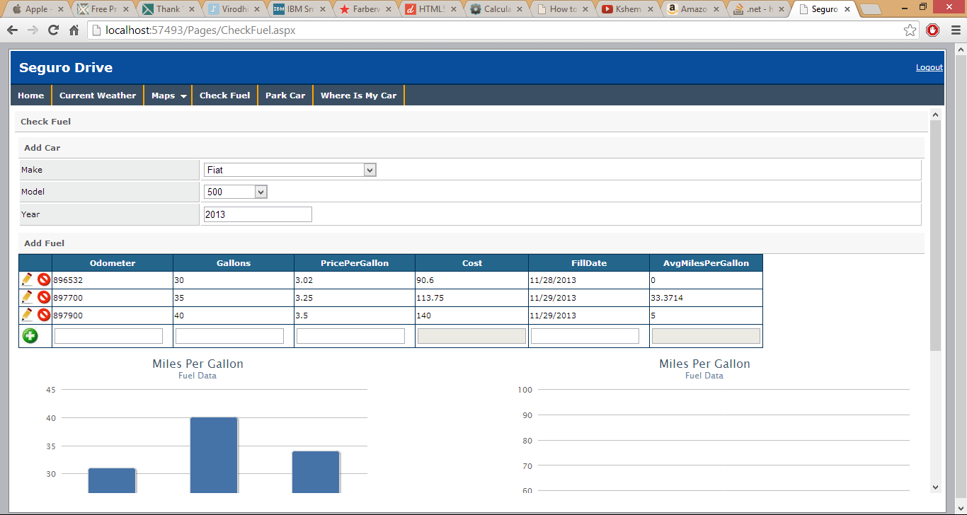
The Odometer readings, Gallons, Cost, Price of Gas, Fill Date needs to be entered and as per the given values the averagemilespergallon is calculated.

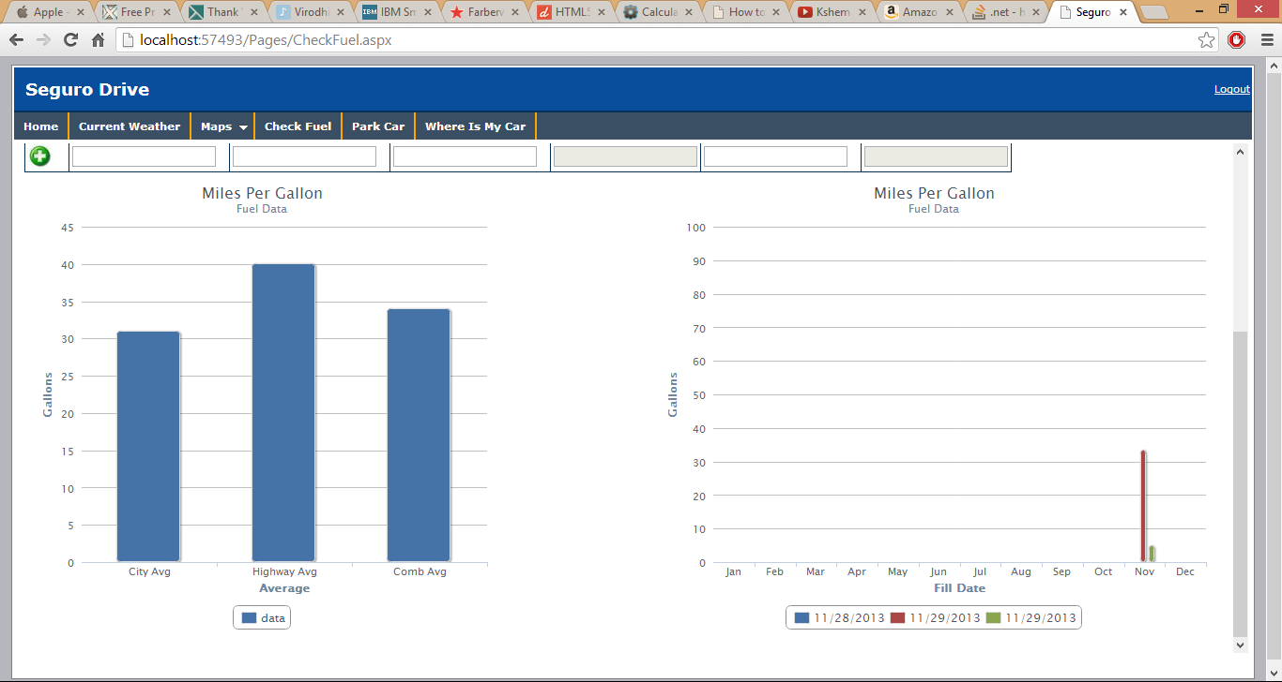

Graph A represents the fuel consumed in different locations on City, Highways and when both are combined in journey.
Graph B represents the Miles per Gallon per date consumed.

Find My Car:
It is divided into two modules-
1. Park Car
2. WhereIsMyCar

Park Car:
In Park Car Service, the car is parked in the parking location and is stored in the database.
Clicking on Get Parking Location Button will extract the user current Latitude and Longitude.
Clicking on Park Button will store the user location in the database.
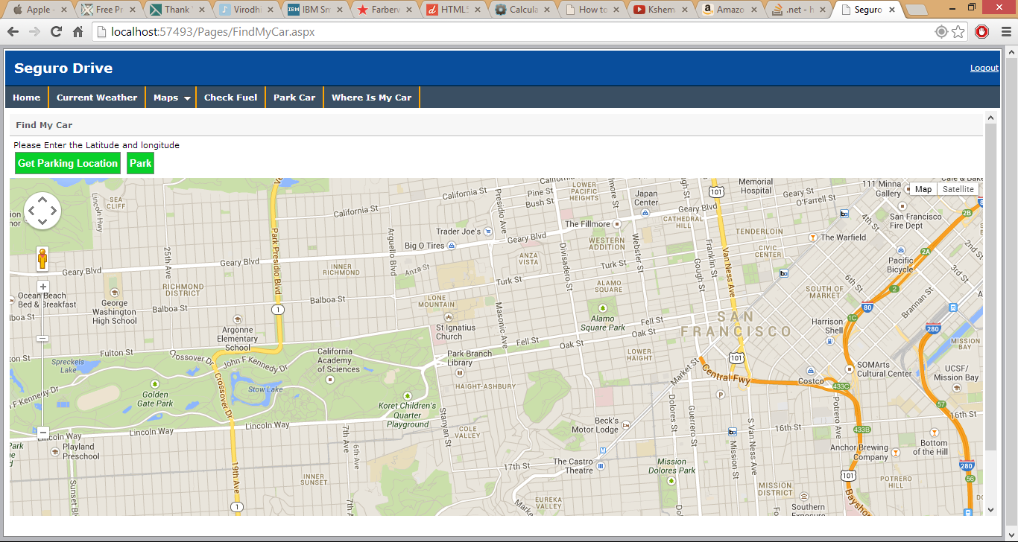

WhereIsMyCar:
In this the User needs to enter the location from where he needs to find his car parked.
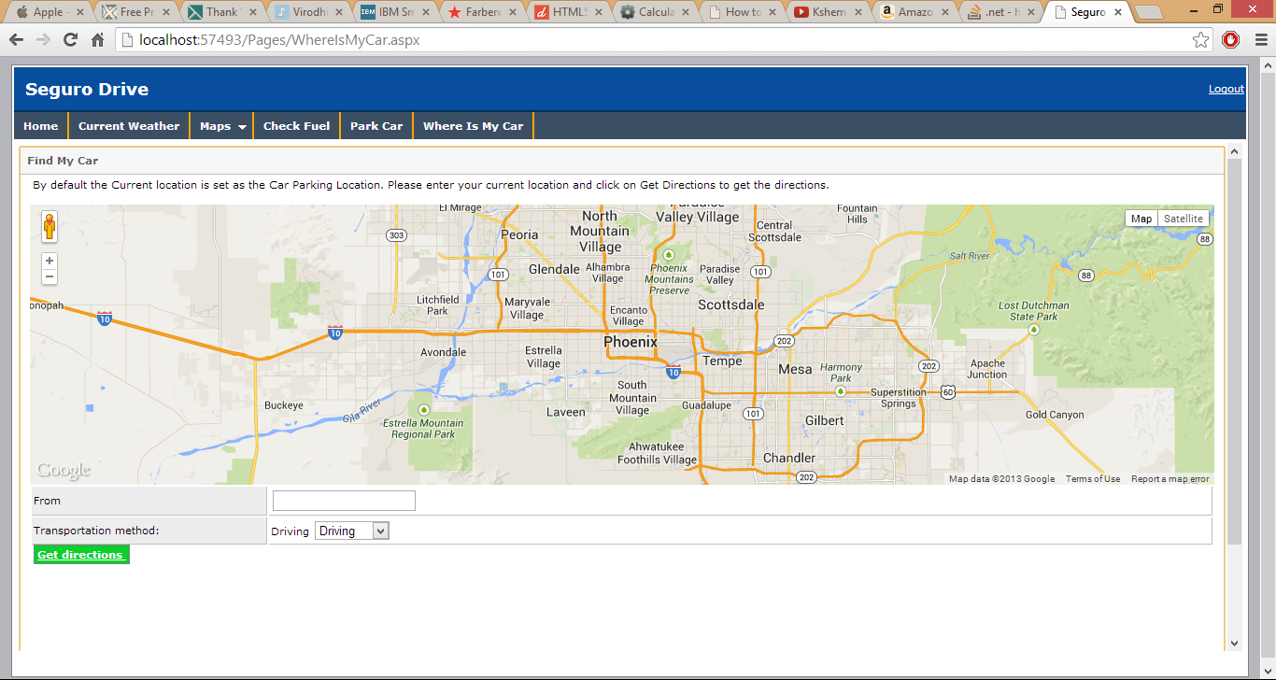
In the From field, enter the location of user and select the transportation methods.
Clicking on Get directions will result in the display of directions from the user location to the location where the car is parked.
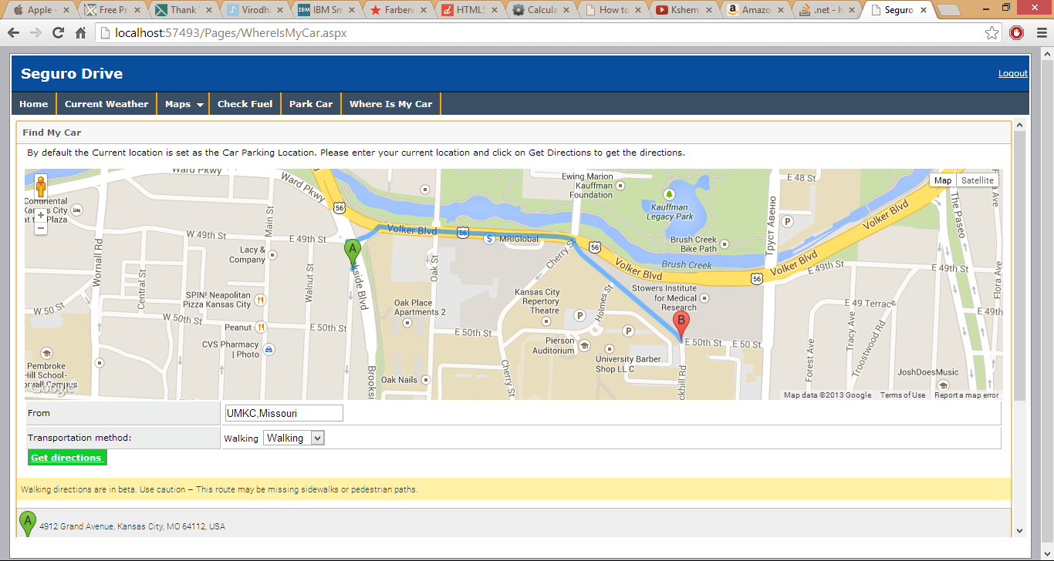
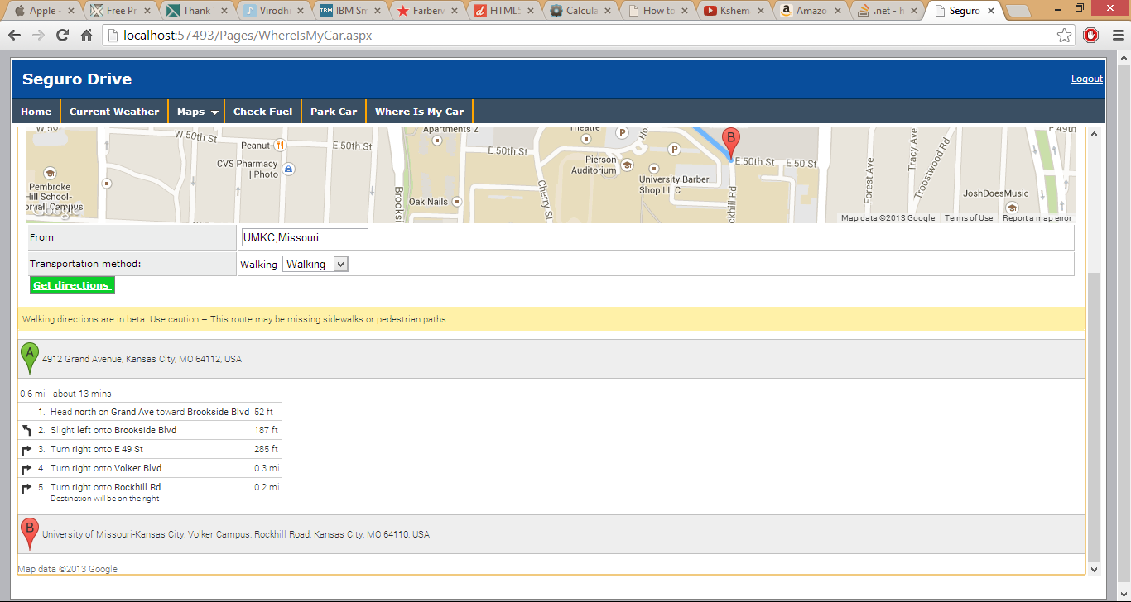
User is in UMKC and selected the transportation method as Walking, hence the steps shows the walking route from the car parked location to the user location.

- Project Management:

Story #4 As a team we want to create login and registration pages so that user can log in to the application.
Story #6 As a team we want to change the front end design so that it looks good with application

In the Fourth Increment, all the work related to project is finished. Hence we can move all the stories from doing phase to finished phase.

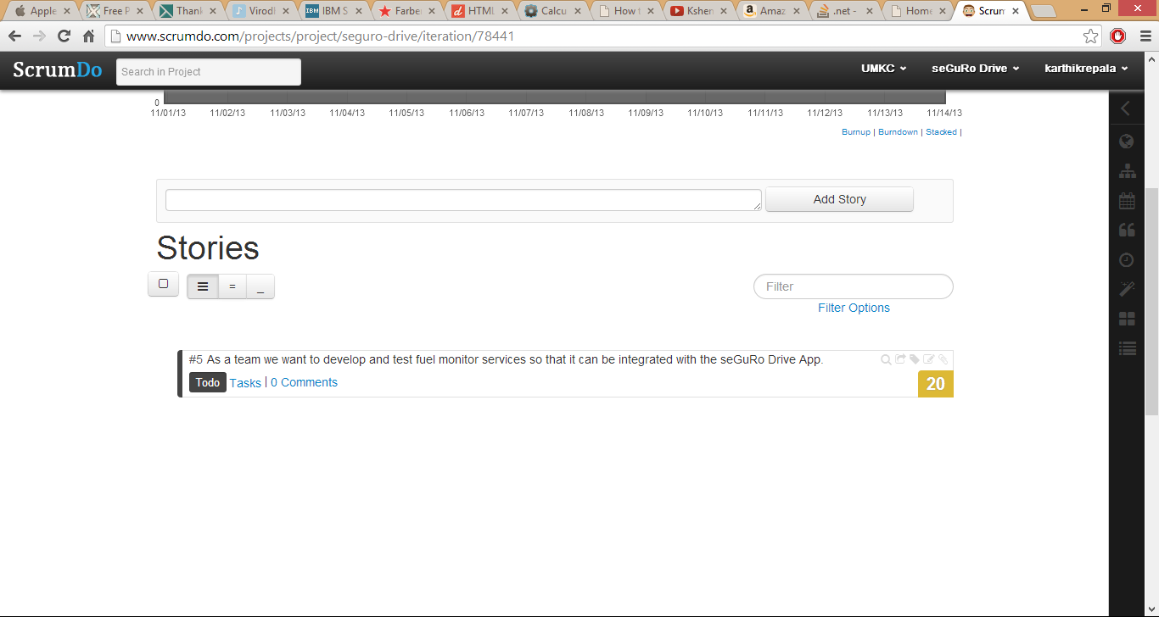
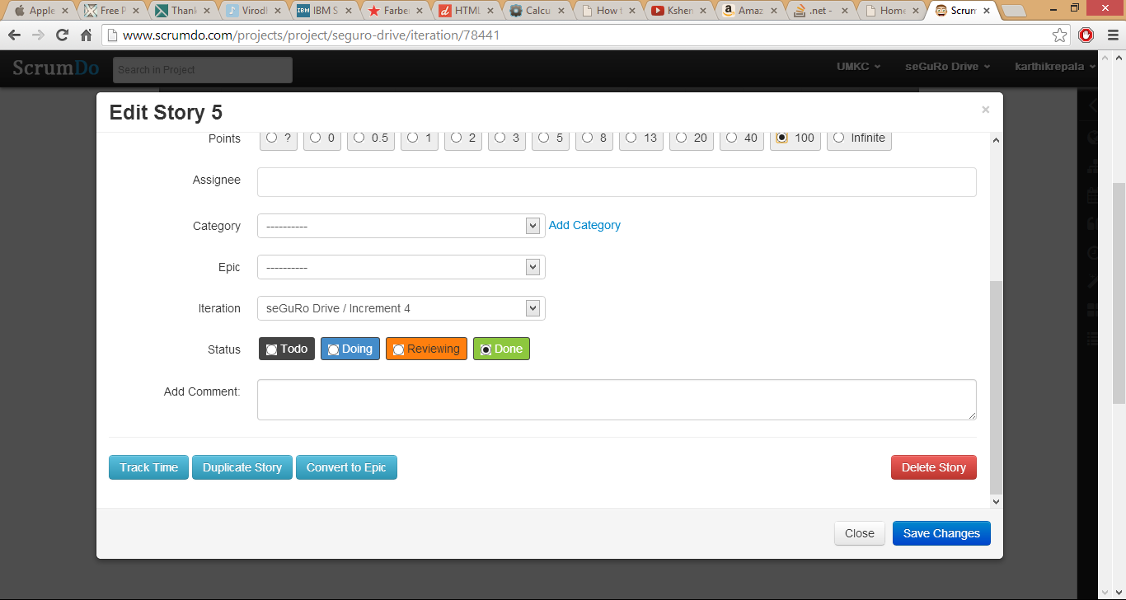

The final view of the Seguro Drive project shows all the stories are completed.
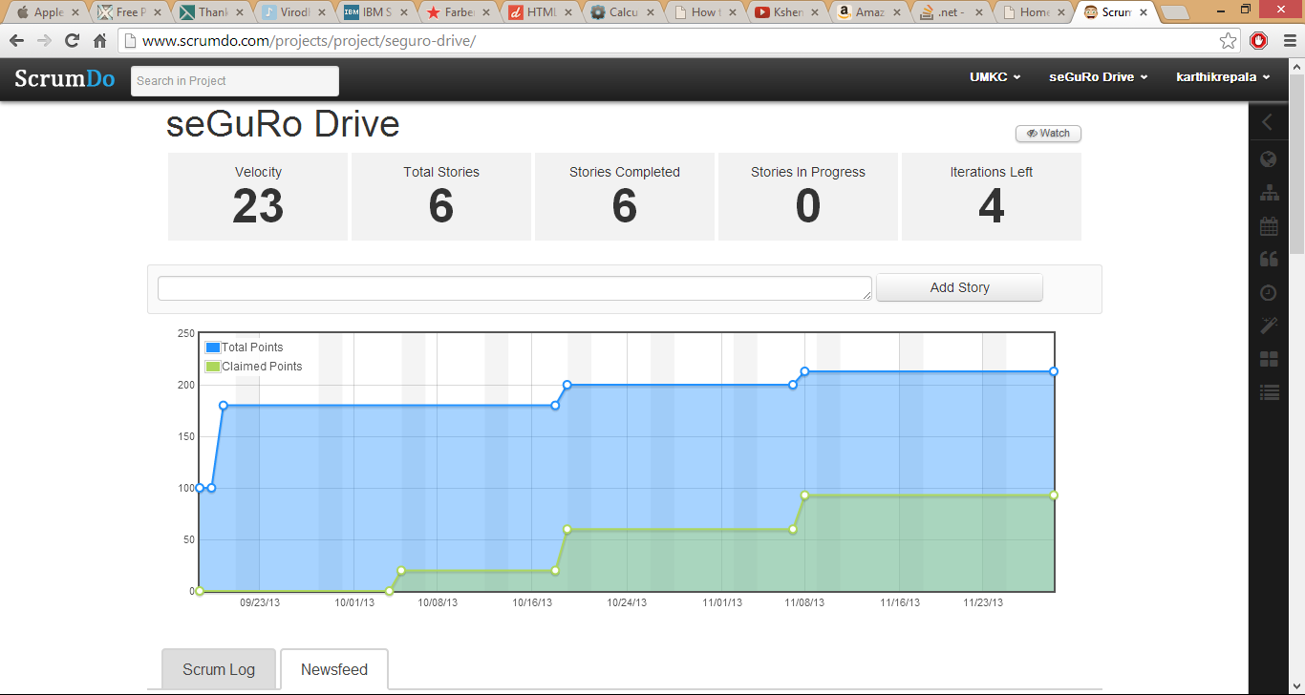

  - Implementation status report

    - Work completed:
      - Check Fuel Service
      - Updating Navigation and Weather Services
      - Cloud Deployment
      - Database Management
      - Time taken (80 hours)
      - Responsibility

Karthik- Check Fuel Module, Creating SQL Tables, Documentation
Shiva-Check Fuel Module, Creating Stored Procedures
Surendra-Updating Weather & Navigation Services, Cloud Deployment

    - Work to be completed
-NIL-

    - Limitation:
User can save only one car under his profile.

